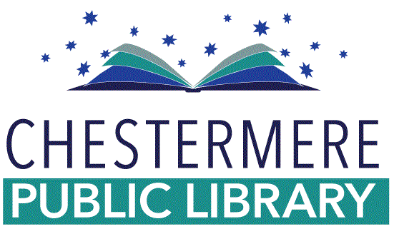
Chestermere Public Library is looking for two summer employees with loads of energy, lots of ideas, and an enthusiasm to serve the community, to join their team for the Summer of 2021. Employment is dependent upon grant funding.

Position: Summer Reading Program Coordinator; Full-Time: 37.5 Hours/week (the program may be delivered online depending on the status of Covid-19)
Dates of Temporary Employment: June 07- August 20, 2021 (a later start date may be considered for High School Students)
Description: The Summer Reading Program Coordinator manages multiple priorities for the creation, implementation, promotion, and evaluation of the library’s summer reading program. The reading program consists of weekly workshops for specific age groups, larger family events, and ongoing encouragement of independent participant reading and learning.

Mandatory Qualifications:
- Must be a returning student, having attended school full-time in the last academic year and intends to return to school for the next academic year;
- Experience working with children ages 3-12;
- Some experience in customer service;
- Loves to read a good book!

Responsibilities:
- Develop and plan a suite of programs and materials that complement the summer reading program theme;
- Create age-specific content and program plans;
- Plan and facilitate larger family events that complement the summer reading program theme;
- Create a registration strategy for participants;
- Work with management to promote the summer reading program;
- Manage a small-scale budget unique to the summer reading program;
- Maintain digital files.

Please email a resume and cover letter to:
Miranda Johnson
Executive Director
Chestermere Public Library
105B Marina Rd
Chestermere, AB T1X 1V7
miranda.johnson@chestermerepubliclibrary.com
403-272-9025

